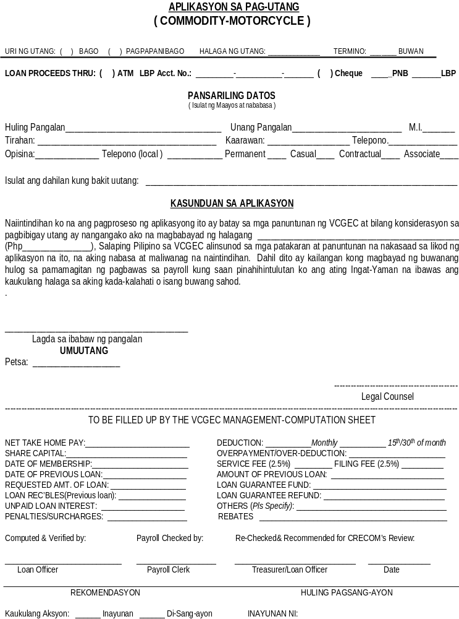

JASMIN M. DIMARANAN  Tagapamahala | Petsa | ATTY. MICHELLE C. BORROMEO  Tagapamahala, BOD | Petsa

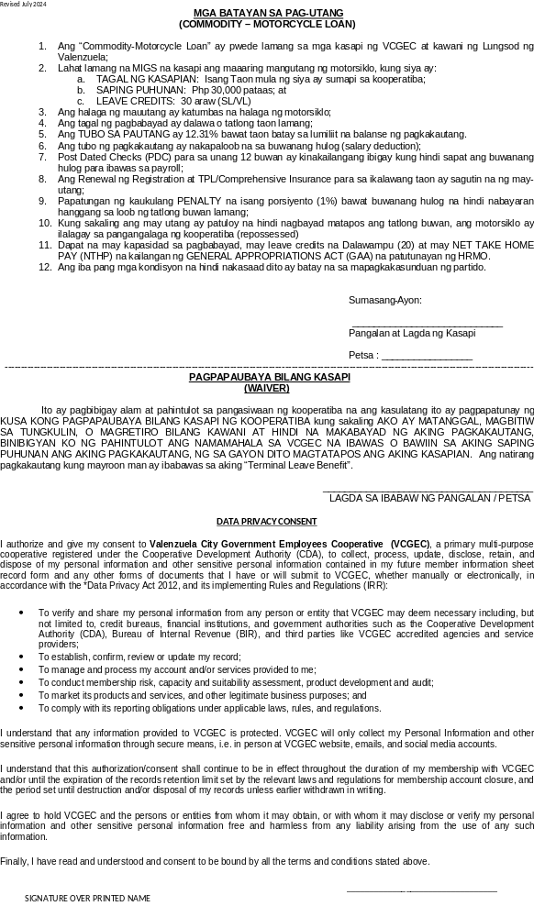
_____________________________________
SIGNATURE OVER PRINTED NAME

